Gonzaga Security Page:

* Password recommendations and change tutorial.
* All headers on main page are at top and take you to the spot in the page.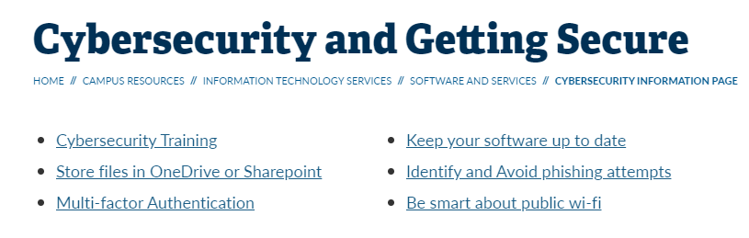
* Uses company (KnowBe4) to train students and faculty annually.
* Gives a quick paragraph on benefits of using one drive rather than local computer files.
* Quick paragraph of MFA importance.
* Reminder to keep up to date with updates.
* Phishing section that breaks down important parts.
* Paragraph explaining danger of public wi-fi

HIP Security Page:

* Repeats cybersecurity awareness campaign in two different places
* Has an example of recent phishing scam in harper but this could be old and could be put into just a list of examples rather than taking up space on the main page.
* Redundancy of password reuse issue
* Video for securing home
  + Who is the site primary meant for and what is its ideal purpose?
  + Where does the secure home connect to that?
* In my opinion there are to many places to look for stuff
  + There are about three different places (carousel, main page, bottom URLs with news) with information but it is unclear where certain things are
* Redundancy issue
  + Ex: Harper outside US 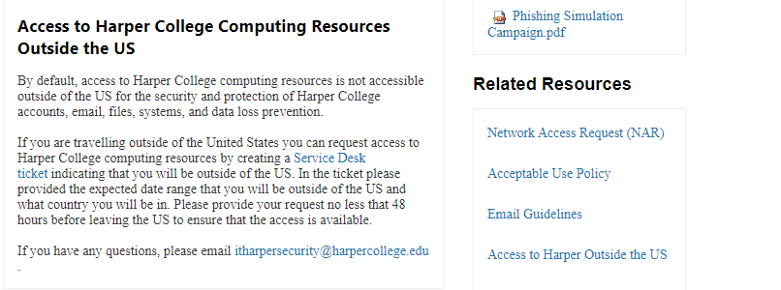
* Solution ideas
  + Consolidate all phishing information to one document that can be navigated to have examples and advice etc.
  + Reduce places to get stuff to carousel and main page.
  + Main page meant for quick points and carousel meant for documents meant to help provide more information.
  + Employee focused
  + Important: contact us, outside us, more information on safety, PII in emails, contact police if crime occurs
  + Personally, I would rather use banners than the carousel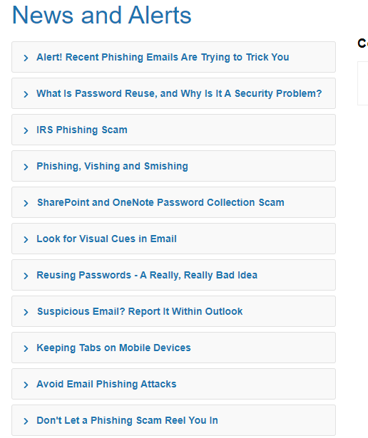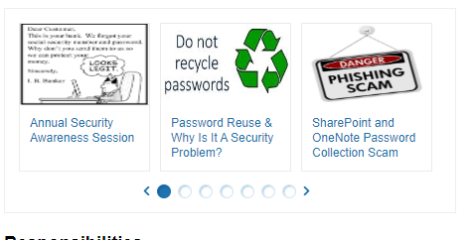
  + The banner allows everything to be seen an feels more organized.
  + Information should be consolidated or removed Ex: human hacking ted talk